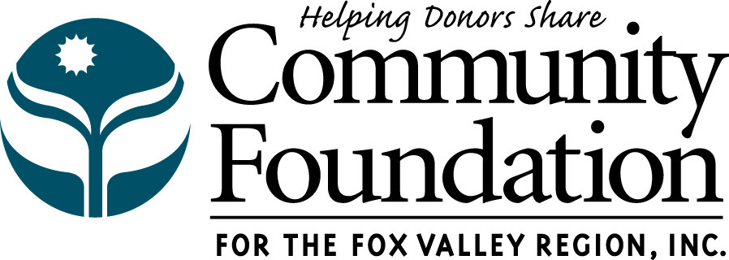
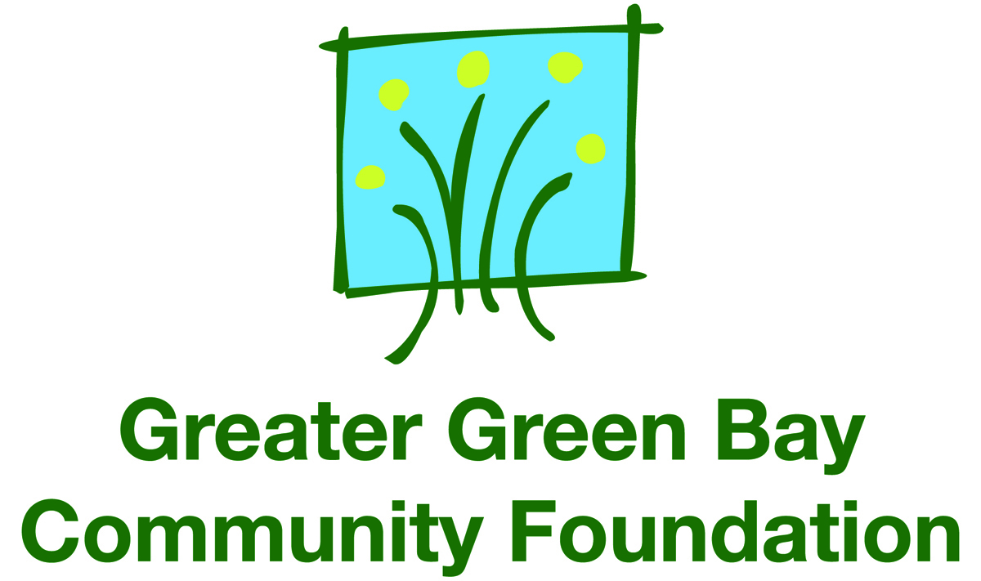
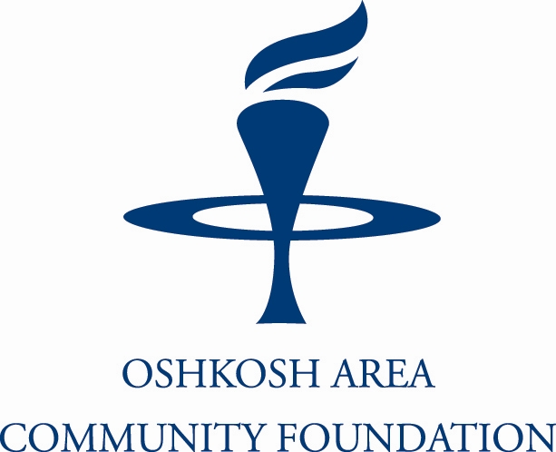

Basic Needs Giving Partnership Regional Grant Application
(DEADLINE: February 15)

Grant Application Process at a Glance

Organizations must use this application when applying for a collaborative grant that involves the service areas of more than one of the regional
community foundations. Regional collaborative grant applications will be considered ONLY IN THE FEBRUARY 15 GRANT CYCLE. Direct your
questions and submit completed initial application to the community foundation in whose service area the lead agency’s main office is located.
The lead agency must be a 501(c)(3) tax-exempt charitable organization.

Name of lead agency* |  |  |  |  |  | * Lead agency must be a  501(c)(3) or other public charity.
EIN number
Community foundation  service areas involved  (Check all that apply) | Community Foundation for the Fox Valley Region (email to bavandenbroek@cffoxvalley.org)  Greater Green Bay Community Foundation (email to amberpaluch@ggbcf.org)  Oshkosh Area Community Foundation (email to Amy Putzer amy@oshkoshareacf.org)
Grant contact’s name
Grant contact’s title
Grant contact’s phone |  | Fax |  | Email
Other agencies  involved in collaboration | 1) |  |  |  |  | 5)
Other agencies  involved in collaboration | 2) |  |  |  |  | 6)
 | 3) |  |  |  |  | 7)
 | 4) |  |  |  |  | 8)

Section 1 – Proposal Overview
Project title
Project start date End date for community foundation support
Total amount requested $ Total project budget $ (for multi-year request, use multi-year total)
List all counties served by this collaborative project
County | Number of clients served | % of total served
 |  | %
 |  | %
 |  | %
 |  | %
 |  | %
 |  | %

Project summary Describe your project in 2-3 concise sentences.

Project long-term objectives and measurement What are the project’s objectives (list up to 3) and how will you measure whether you have achieved them?

Total project budget List sources of revenue and types of expenses below. Identify the specific expense line items to which Community Foundation (CF) grant dollars would be applied.
Revenue |  | Total amount | Approved? |  |  | Expenses |  | Total amount |  | CF support
Community Foundation | $ | 0 |  |  |  | Salaries/Benefits | $ |  | $
Agency Contribution | $ |  |  |  |  | Contracted Services (detail below) | $ |  | $
Fees for Service | $ |  |  | If no, indicate  decision date |  | Supplies/Equip. (detail below) | $ |  | $
Membership Dues | $ |  |  | If no, indicate  decision date |  | In-Kind Expenditures | $ | 0 | $
In-Kind Contributions | $ |  |  | If no, indicate  decision date |  | Advertising | $ |  | $
Grants/Other Funders (list) |  |  |  | If no, indicate  decision date |  | Printing | $ |  | $
 | $ |  |  | Yes |  | Other (list)
 | $ |  |  | Yes |  |  | $ |  | $
 | $ |  |  | Yes |  |  | $ |  | $
 | $ |  |  | Yes |  |  | $ |  | $
Total | $ | 0 |  |  |  | Total | $ | 0 | $ | 0
 | $0  Total should equal total project budget on pg 1 |  |  |  |  |  | $0  Total should equal total project budget on pg 1 |  | $0  Should equal total requested on pg 1

Project budget narrative Briefly explain revenue sources and expense details. Be specific about how grant dollars from the community foundations would be spent.

Section 2 – Collaborating Organizations
A copy of Section 2 must be completed in full by each collaborating organization.

Collaborating organization’s name
Is organization a 501(c)(3) or other public charity? |  |  |  |  |  | YES |  |  | NO | EIN number
Organization’s address
Number full-time employees |  |  | Number of part-time employees |  |  |  |  |  |  |  |  |  | Number of volunteers
Grant contact’s name
Grant contact’s title
Grant contact’s phone |  |  | Fax |  |  |  |  | Email
Organization’s mission
Describe role in project
(include monetary, in-kind and personnel contributions, core responsibilities and how project relates to your mission)

Income statement Provide actual data for your organization’s three most recently completed fiscal years, starting with the most recent. Data should reconcile with your audited financial statements. Organizations/divisions with a parent office should provide their specific operating budget for regional or local office.

Income statement | Total  Revenue |  | Earned Income  (i.e. program or membership fees) |  | Total  Expenses |  | Surplus or (Deficit)
FY | $ |  | $ |  | $ |  | $
FY | $ |  | $ |  | $ |  | $
FY | $ |  | $ |  | $ |  | $

Income statement narrative Briefly explain any operating deficits and indicate how the deficits were covered. If your organization has a substantial surplus that is not being used to support the proposed project, please explain.

Balance sheet Provide actual data for your organization’s three most recently completed fiscal years, starting with the most recent. Data should reconcile with your audited financial statements.

Balance sheet | Cash  (checking and savings) |  | Accounts  Receivable |  | Current Liabilities |  | Loans
FY | $ |  | $ |  | $ |  | $
FY | $ |  | $ |  | $ |  | $
FY | $ |  | $ |  | $ |  | $

Section 3 – Executive Summary
Describe your project in more detail. (maximum 2,000 characters)

Answer the following questions (maximum 500 characters each):
What is the need for this project?

Who will benefit from the project and how?

What is the project timeline?

How does this project address one or more of the funding priorities of the Basic Needs Giving Partnership?

How does this project address the root causes of poverty?

How will the initiative be sustained in the future?

Optional: State any additional information you would like to provide.

