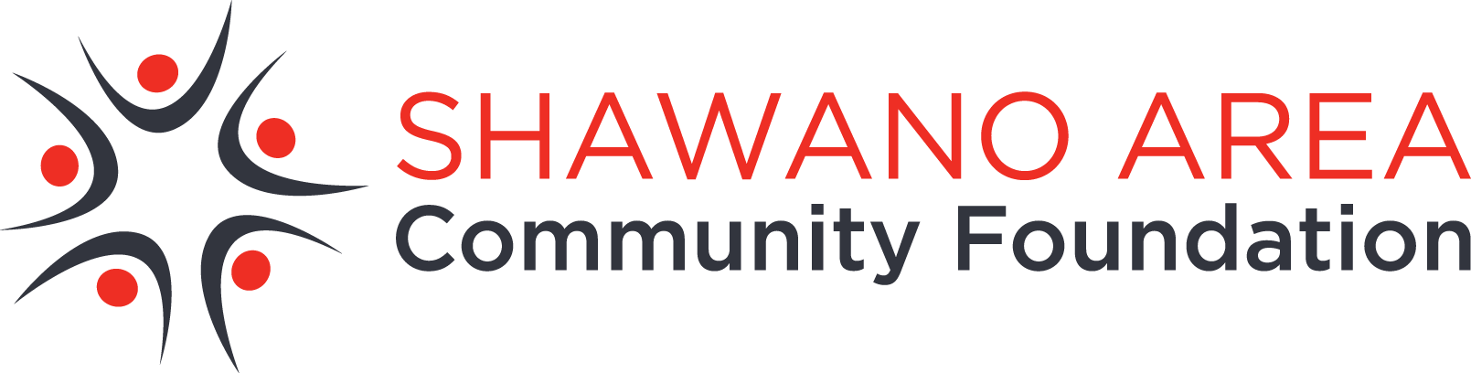
NEWS RELEASE

FOR RELEASE
Aug. 19, 2016

For more information, contact: Gail Bartz, Grants Committee Chair, 715-853-1428

Grants available for Shawano area charitable organizations

SHAWANO, WI - The Shawano Area Community Foundation (SACF) is accepting grant applications until October 1 from eligible Shawano area charitable organizations.

Organizations interested in applying for grants up to $5,000 from the SACF’s Shawano Area Fund must be designated by the Internal Revenue Service to be public charities. This encompasses most charitable, scientific, social service, educational and religious organizations described in 501(c)(3) of the tax code, as well as government agencies. Organizations that are not public charities may apply through a fiscal sponsor.

Grants support projects or programs in the areas of arts and culture, health, human services, community development, education and the environment. Priority will be given to proposals with clear goals and financial accountability, and for which a moderate amount of grant money can make a significant impact on an area of need.

Grant guidelines and an application form can be found online at www.ShawanoFoundation.org. For more information or assistance, contact Gail Bartz, board member with the Shawano Area Community Foundation at 715-853-1428.
2015 Shawano Area Fund Grant Recipients

In 2015, grants totaling $29,840 were awarded to 8 organizations:
Alzheimer's Association Greater Wisconsin - To provide program support for Shawano Area Memory Cafés to reduce isolation individuals who suffer from dementia, and their caregivers. Amount awarded: $3,000

Belle Plaine EMS - To purchase AED machines to provide faster cardiac care to Belle Plaine patients until advanced care arrives. Amount awarded: $2,500

Boys & Girls Club of Shawano - To support the printing and advertising costs associated with creating awareness of the newly formed Boys & Girls Club charter in Shawano, which is working to address a void in community youth programming. Amount awarded: $1,940

CHAPS Academy - To provide psychiatric support for children from Shawano County who are suffering from mental illness and take part in the Hope Lives suicide prevention and intervention program. Amount awarded: $2,500

Junior Achievement of Wisconsin in Wolf River District - To support expenses for Shawano County youth interested in attending a summer camp focused on building entrepreneurial skills. Amount awarded: $2,500

Lutheran Counseling & Family Services of Wisconsin - To support mental health counseling sessions for Shawano County clients who are unable to pay the full cost of their services. Amount awarded: $2,000

Navarino Nature Center - To support the production of trail maps and replace outdated trail signage. Amount awarded: $2,500

Navarino-Lessor EMS First Responders - To purchase two portable radios which will replace outdated equipment. Amount awarded: $5,000

nIc Foundation - To support the purchase of supplies and marketing expenses associated with Character Camp, a summer camp experience for children in grades 4k-5th in Shawano County. Amount awarded: $1,200

Safe Haven Domestic Abuse Support Center - To provide clients with computer and internet access to assist with their job searches and other activities required for becoming self-sufficient. Will also provide keyless entry to client rooms, which will offer more privacy. Amount awarded: $1,700

Shawano County - To support training instructors and purchasing equipment to expand the Strong Women, Strong Bones program that takes place in rural areas of Shawano County. Amount awarded: $5,000
The SACF was established in 1990 by community volunteers to preserve and improve the quality of life in Shawano and the surrounding area. It is an affiliate of the Appleton-based Community Foundation for the Fox Valley Region, the second-largest community foundation in Wisconsin (www.cffoxvalley.org). More information about the SACF is available online at www.ShawanoFoundation.org, by calling 920-830-1290, or by emailing info@shawanofoundation.org.
###

