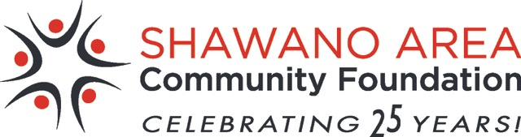
25th Annual Charitable Golf Outing
Tuesday, June 21, 2016
Shawano Lake Golf Course
W5714 Lake Dr.
Shawano, WI

NEW DATE - REGISTER NOW!!!

Please join us for a day of fun, food and fellowship at our 25th Annual Charitable Golf Outing! A $400 Foursome Package includes 18 holes of golf with power carts for four players, lunch on the course, special events on every hole, a great dinner and a contribution to the Shawano Area Community Foundation’s Shawano Fund to benefit local community needs.

SCHEDULE OF EVENTS
11:00 AM – Registration
12 NOON – 18 Hole Shotgun Start (Scramble Format)
*Lunch provided on the course*
5:00 PM – Social Hour (non-golfing guests welcome)
5:30 PM – Dinner (non-golfing guests welcome) & Awards

What a neat way to have a great day and support your local community at the same time! This year we hope to raise enough to grant more than $20,000 to area nonprofit organizations, but we need your help. Register your foursome today! Please include your handicap or 18-hole average for our scorekeeper. Don’t have a foursome, but still want to participate? Submit an individual entry and we’ll arrange a foursome for you. Not a golfer? Sponsor a hole for $100 and we’ll recognize your family/company on a sign at the tee. Dinner guests are welcome, too! Come out early, watch a little golf, and visit with friends.
Help celebrate 25 years of giving in Shawano!!!!
Please fill in the registration form below and return it with your check today.
-------------------------------------------------- ------CUT HERE-----------------------------------------------------
REGISTRATION FORM
TEAM CONTACT:

Name: ____________________________________________

Address: ___________________________________________

____________________________________________

Phone: _____________ Email: ________________________
GOLFERS @ $100 ea.¹
1) _________________________________________

2) _________________________________________

3) _________________________________________

4) _________________________________________

DINNER GUESTS @ $25 ea.²
___ I/We are not able to attend, but I/we support our community.
Enclosed is a tax deductible gift of $_________

Make Checks Payable to: SACF-Golf

Mail Form to: Shawano Lake Golf Course
W5714 Lake Dr.
Shawanol, WI 54166
Email inquiries to: traether@charter.net
1) _____________________________________

2) _____________________________________

HOLE SPONSORSHIP $100

Sign Info: ___________________________________________

1-The cost per golfer is $100, which includes a round of golf, cart, lunch, and dinner valued at $50 and therefore not tax-deductible.
2- The cost per dinner guest is $25, which includes dinner valued at $15 and therefore not tax-deductible.

The Shawano Area Community Foundation is an affiliate of the Community Foundation for the Fox Valley Region

